**Ansh Ranjan  
Azure Data Factory**

**Exercise 1: Setting Up Azure Databricks & Spark Basics**

**TASK 1: Create a new Azure Databricks workspace.**

1. Go to Data Factories > Create > Enter details   
   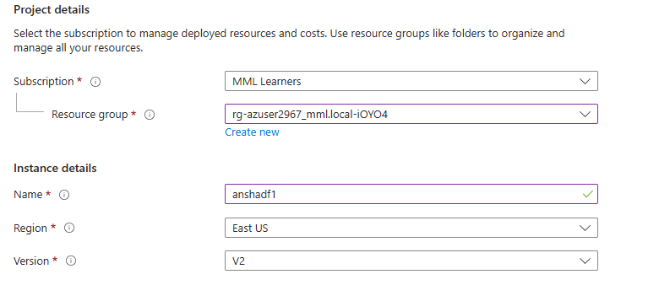

**TASK 2 & 3: Download the dataset and Upload to Blob Storage**

1. Go to your storage account > Storage Browser side tab > Blob Containers > select a blob container to upload your dataset > click on Upload   
   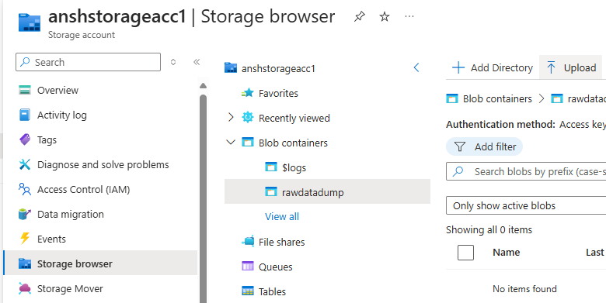
2. Browse for your dataset csv file and hit Upload   
   